



**Table of Contents**

About this guide 4

Meaning of the terms ‘Manager’ and ‘Person having control’. 4

Person having/in control 4

Person Managing 4

Explained in simple terms 5

1. Before you commence your online application 6

1.1. Things you need in order to complete the application 6

1.2. Information for applicants applying for multiple properties 6

1.3. Registering for an account to facilitate ‘Save and Exit’ 7

1.4. Using the ‘Save and Exit’ function 8

2. Making an application 8

2.1. Address Search 8

2.2. Type of Application 9

2.3. Local Authority visit or intervention. 9

2.4 Applicant Details (Details of Person filling out this Form) 9

If the applicant is not the Proposed Licence Holder 10

If the applicant is the Proposed Licence Holder and will manage the property 10

If the applicant is the Proposed Licence Holder but there are other people involved in the management of the property 10

2.5. Details of Person filling out this Form 10

2.6. Details of person(s) to be named on the licence (Proposed Licence Holder) 11

2.7. Other Licensed Properties 12

2.8. Fit and Proper Persons 12

2.9. Details of the Person Receiving the Rent 13

2.10. Details of Property Manager 13

2.11. Accreditation Schemes 13

2.12. Ownership details 14

2.13 Details of Freeholders and Leaseholders 14

2.14. Mortgage 15

2.15 Charges 15

2.16. Fit and Proper Declarations 15

2.17. Property Management 16

2.18. Details of the Property 17

2.19. File upload page 17

2.20. Supporting Documentation 18

2.21. Notification Requirements and Notification Declaration 18

2.22. Declarations (Final Declaration) 19

2.23. Email confirmation 19

2.24. Fee Breakdown 20

2.25. Application Review 20

2.26. Payment Screen 20

# About this guide

This guide was created to assist with applications for property licenses in the Gedling Borough Council district using the online application from. The online application form is provided by an external company and was not designed by Gedling Borough Council.

We have worked closely with the developer to make the form as user friendly as possible. The form is a generic template used by a number of councils across the country. We have modified it as much as possible however there are some parts which couldn’t be changed. It is therefore highly recommended that you use this guide as a point of reference when filling out your application.

The route through the online application is dependent on the data entered by the user. Therefore it may be that when completing your application form this user guide does not follow the exact same path as what is on your screen. Each section of this report has headers taken from the online application so if you need guidance on a specific part of the online application use the table of contents at the start of this guide to navigate to the relevant section.

# Meaning of the terms ‘Manager’ and ‘Person having control’.

The definition of ‘Manager’ and ‘Person having control’ is defined within Section 263 of the Housing Act 2004:

### Person having/in control

The person having control means the person who receives the rack rent of the premises (whether on his own account or as an agent or trustee of another person), or who would receive it if the premises were let at a rack rent.

### Person Managing

“Person managing” means, in relation to premises, the person who, being an owner or lessee of the premises;

1. Receives (whether directly or through an agent or trustee) rents or other payments from;

* In the case of a house in multiple occupation, persons who are in occupation as tenants or licensees of parts of the premises; and
* In the case of selective licensing, persons who are in occupation as tenants or licensees of parts of the premises, or of the whole of the premises; or

2. Would so receive those rents or other payments but for having entered into an arrangement (whether in pursuance of a court order or otherwise) with another person who is not an owner or lessee of the premises by virtue of which that other person receives the rents or other payments;

and includes, where those rents or other payments are received through another person as agent or trustee, that other person.

### Explained in simple terms

The licence holder must be the most appropriate person which generally means that they must be the one in control and the one who receives the rent. The licence holder will be bound by the licence conditions and should be competent. Generally speaking this is the owner of the property however in some cases properties are fully run and managed by a managing agent and the landlord takes a back seat and leaves all management to the agent. If an agent is in full control of the property (receives the rent, provides the day to day management and is fully authorised to carry out repairs) then they would be the ‘person having control’ and as such they would be the most appropriate ‘person’ to hold the licence.

Where an individual owns a property but has an agent in place that carries out the day to day management on their behalf it might be that the landlord is still the person in control and the agent is more the manager. The manager can be an agent/employee of the person having control of the property. If the landlord is still involved in decision making i.e. all repair requests go through the landlord and he/she received the rent either directly or via the agent etc. then it could be that the landlord is still the person having control and as such the landlord would be the Licence Holder and the Agent would be on the licence as the Manager.

If the licence holder does not live locally to the property then we would expect that a locally based manager would be involved to assist with the day to day management of the property.

# Before you commence your online application

## Things you need in order to complete the application

In order to complete the online application you will need the following:

* Scanned copies of all essential documentation:

**Selective Application -** A valid Gas Safety certificate (if the property has a gas supply), a fixed electrical installation test certificate (i.e. EICR) completed within the last five years, Fit and Proper Persons Form (downloadable from our website) filled out and signed by relevant parties

**HMO Application -** A valid Gas Safety certificate (if the property has a gas supply), Fit and Proper Persons Form (downloadable from our website) filled out and signed by relevant parties, Property floor plans.

and any additional information you wish to attach to your application which isn’t required but you feel would be relevant (Energy Performance Certificate Emergency Performance Certificate, Fire Alarm Testing Certificate, Portable Appliance Testing Certificates etc.)

* A Debit Card or Credit Card
* Read the ‘About this guide’ section above.

## Information for applicants applying for multiple properties

If you are applying for multiple properties an application needs to be made for each property. This process can be expedited by setting your web browser to auto populate fields within the form. Once you have entered the information on the form once, when you come to apply for your second property the information previously typed will automatically populate.

For Google Chrome, this setting is turned on as default however if you need to enable it again do the following:

1. Click on the Chrome menu icon (Three lines at top right of screen)
2. Click on Settings
3. At the bottom of the page click “Show advanced Settings”
4. In the ‘Passwords and forms’ section ensure that ‘Enable Autofill to fill out forms in a single click’ is enabled.

For Windows Edge you can save addresses so that they automatically populate in the form. To activate this you may need to do the following:

1. Click on the three dots in the top right of the browser window
2. Select *Settings > Profiles > Addresses* *and more*
3. Select the *Save and Fill addresses* toggle to turn it on
4. Choose *Add address.* Enter a new address and *Save*
5. To change or delete saved information select either *edit* or *delete*

Certain fields such as the question which asks whether the applicant has any other licensable properties is an open text box which allows up to 500 characters. To speed up the process when making multiple applications it is recommended that you record this information in a separate word document and either copy and paste it into the text box for each application or add the word document as an attachment on the file upload page.

## Registering for an account to facilitate ‘Save and Exit’

The form has a ‘Save and Exit’ facility which allows you to save information you have already added and come back to it at a later date. In order for this to work you must register an account with Idox who provide the application software.



To register for an account click the “Log in to save” button at the top of the page

You will then be asked either to log in or register for an account. Click to register an account and enter the information requested. You will then receive an email with a verifcation link which you need to click to complete registration.

Once you have set up your account and verified it via your email address you should be logged in on the application portal. You can tell that you are logged in when the ‘Log in to save” is replaced with “saved as draft”. If your page is still displaying ‘Log in to save’ at the top then click it and enter your log in details.

**Note:** Any saved applications will only be held by iDOX for 30 days so you must return to, and complete you application within that time. After 30 days saved applications will be deleted.

If you have registered with iDOX and saved an application you will receive and email in 30 days to say your application has been deleted even if you have already paid the fee and submitted the application. Please rest assured that iDOX removing stored saved applications does not affect your submitted application in anyway.

## Using the ‘Save and Exit’ function

At any point during the application where the ‘save and exit’ button is displayed you can click the button to save all progress and exit the application. All data you have entered will then be saved so that you can continue the application at a later date. To access your saved applications you need to use the following link:

[Login : Idox Digital Platform (idoxgroup.com)](https://identity.idoxgroup.com/uaa/login)

**Note:** Please be mindful that your session may timeout if you leave the application form open and inactive for a long period of time. It is recommended that you save the application periodically as you progress through.

Only one browser window can be used at a time when applying for a licence. If you try and open a second browser whilst still having the existing application open the new window will not allow you onto the application portal. To rectify this issue ensure all existing windows are closed prior to opening a new application window on the browser.

# Making an application

To start a new application for either a HMO Licence or Selective Licence, either follow this link: [New Residential Licence (idoxds.com)](https://gedling.idoxds.com/dsfx/xp/text/load?xps=DSFX1661438584692) or navigate to our website using this link: [Selective Licensing - Gedling Borough Council](https://www.gedling.gov.uk/resident/housing/selectivelicensing/) and click the green button entitled “Apply now”.

## 2.1. Address Search

The first page you will be met with asks for the address of the property you are making the application for. The address field is confined to addresses within the Gedling Borough Council area.

If you are applying for a Selective Licence, ensure that you have verified that the property falls within one of the Selective Licensing Areas using the interactive map found here: [Selective Licensing Areas (arcgis.com)](https://gedlingbc.maps.arcgis.com/apps/webappviewer/index.html?id=a2db476cb8544d06a20cf6ae38af42cd) All Selective licensing areas are highlighted in blue on the map and you can use the search bar to search for the property in question using postcode:

* Search for your address using postcode and click search.
* Select the property from the list and click next.

## 2.2. Type of Application

Here you need to indicate whether you are applying for a Selective Licence or Mandatory Licence.

* Selective Licencing applies to the ward of Netherfield and certain prescribed areas of Carlton Hill, Newstead, Daybrook and Colwick. It covers all private rented properties within the prescribed areas that otherwise do no fall under Mandatory Licensing (see below). Use this interactive map so see if a property falls within one of the five areas within the Borough covered by selective licensing [ArcGIS Web Application](https://gedlingbc.maps.arcgis.com/apps/webappviewer/index.html?id=a2db476cb8544d06a20cf6ae38af42cd)
* Mandatory Licensing applies to shared houses with 5 or more individuals living as two or more separate households. Note: this isn’t determined on the number of bedrooms; it is purely based on number of occupiers. If a three bed house has a couple living in each of the bedrooms it would need licensing under the Mandatory Scheme.

If your property meets this description but falls within the Selective Licensing area you will still be required to apply for a Mandatory Licence, not a Selective Licence.

## 2.3. Local Authority visit or intervention.

Gedling Borough Council will undertake proactive work to establish whether there are properties being rented out which are unlicensed

(The term unlicensed is in reference to a licensable property where no application has been made and/or no licence in place). If your application is as a result of Gedling Borough Council chasing you for an application then you need to select ‘Yes’ for the question below. 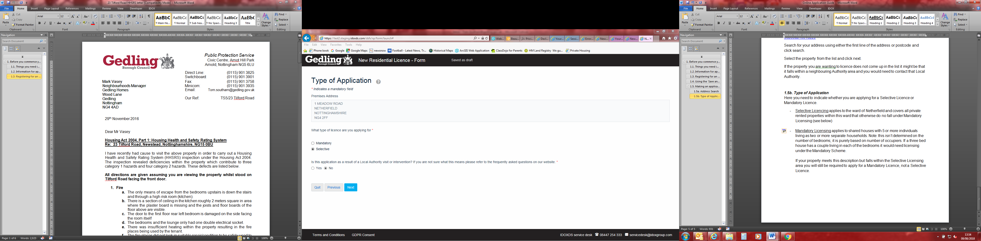

## 2.4 Applicant Details (Details of Person filling out this Form)

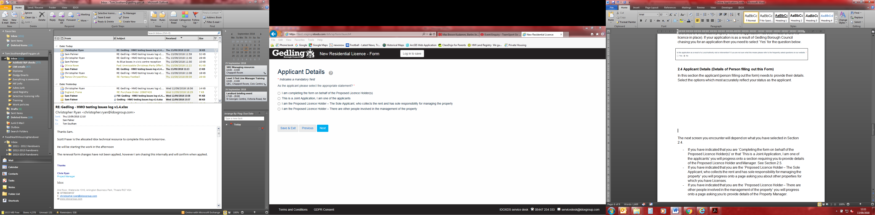In this section the applicant (person filling out the form) needs to provide their details. Select the options which most accurately reflect your status as the applicant.

### If the applicant is not the Proposed Licence Holder

If you are making the application on behalf of someone else i.e you are a Managing Agent completing the form on behalf of the landlord and it is the landlord who is to be the Licence Holder select the top option.

### If the applicant is the Proposed Licence Holder and will manage the property

If you are making the application and you wish to be the Licence Holder and you carry out all management related activities select: *‘I am the Proposed Licence Holder – The Sole Applicant, who collects the rent and has sole responsibility for managing the property’*

### If the applicant is the Proposed Licence Holder but there are other people involved in the management of the property

If you are making the application and you wish to be the Licence Holder but there is someone else who manages the property, collects the rent to then be passed on to you etc. then select the bottom option: *‘I am the Proposed Licence Holder – There are other people involved in the management of the property’.*

**Note:** It is not foreseen that the second option – *‘This is a Joint Application, I am one of the applicants’* will be needed as the above three scenarios cover the majority of circumstances. See FAQs “I have read the online application guide and am confused by the applicant details section” question for further information.

The next screen you encounter will depend on what option you have selected above.

* If you have indicated that you are *‘Completing the form on behalf of the Proposed Licence Holder(s)’* you will progress onto a page asking for your details as the Applicant. **Section 2.5 of this guide.**
* If you have indicated that you are the *‘Proposed Licence Holder – The Sole Applicant, who collects the rent and has sole responsibility for managing the property’* you will progress onto a page asking for the details of the Proposed Licence holder. **Section 2.6 of this guide.**
* If you have indicated that you are the *‘Proposed Licence Holder – There are other people involved in the management of the property*’ you will progress into the section of the form requiring details of the Proposed Licence Holder and Property Manager. **Section 2.6 of this guide.**

## 2.5. Details of Person filling out this Form

You will be directed to this page if the person applying for the licence is different to the Proposed Licence Holder. We need the applicant’s details so that we can send the licence documentation to them.

The first screen you encounter will ask the following:

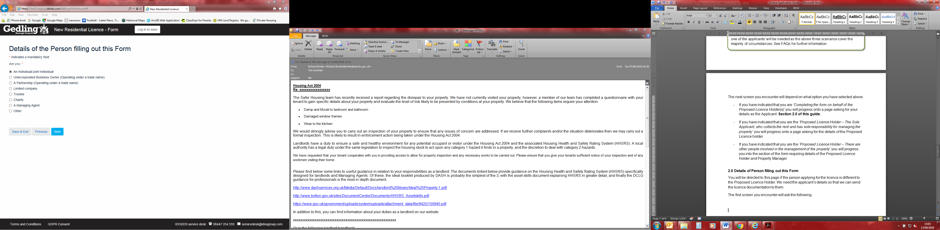

Select the option which most accurately applies. You will then progress onto a page requiring you to provide your details as the applicant.

**Note:** If you select the option “Individual” there will be a box on the next page asking for a ‘Trading Name’. This is not a mandatory field so if this does not apply to you please leave this field blank.

When entering date of birth information you can type the date manually in the following format Day/Month/Year **/**/**** or alternatively use the calendar drop down and select the date using the mouse.

## 2.6. Details of person(s) to be named on the licence (Proposed Licence Holder)

The format of data entry here is the same as in **Section 2.5** above. You may have bypassed the stage as detailed in Section 2.5 because you have declared you are to be the Proposed Licence holder and the applicant.

Enter the information of the person who will be the Licence Holder. The Licence Holder must be the person having control and have the means both in terms of finances and permission to carry out repair. Usually this is also the person who collects the rack rent. The rent doesn’t necessarily need to go direct to the Proposed Licence holder from the tenants; it can go via an Agent.

It is permitted to have more than one licence holder on the licence if there is more than one person/company having control. In order to be a licence holder that person or company must be in control. See FAQs for further information.

**Note:** All licence holders are jointly responsible and liable for compliance with the licence conditions. If there is a breach of a licence condition and enforcement action is taken, the council will consider all licence holders jointly liable.

In order to add a secondary licence holder select the tick box at the bottom of the screen.

**Note:** If you select the option “Individual” there will be a box on the next page asking for a ‘Trading Name’. This is not a mandatory field so if this does not apply to you please leave this field blank.

When entering date of birth information you can type the date manually in the following format Day/Month/Year **/**/**** or alternatively use the calendar drop down and select the date using the mouse.

## 2.7. Other Licensed Properties

If you answered ‘Yes’ include details in the box provided. The box allows 500 characters. If you need additional space provide the information on an additional sheet and attach it to your application using the file uploader later on in the application.

**Tip:** If you are applying for numerous licenses write out this information into a separate word document then copy and paste into the text box when completing each application.

## 2.8. Fit and Proper Persons

If you selected *‘Proposed Licence Holder – The Sole Applicant, who collects the rent and has sole responsibility for managing the property’* at the start of the application process, you will now be directed to the Fit and Proper Persons section of the application. Here you will be asked a series of questions relating to past offences.

Each question is mandatory and must be answered with either ‘Yes’ or ‘No’ using the check boxes. If the answer is ‘Yes’ to any of the questions further details will be required using the boxes provided. It is not necessary to disclose convictions which are spent under the Rehabilitation of Offenders Act 1974.

**Note: You will only be directed to the Fit and Proper Persons part of the form if you selected** *‘Proposed Licence Holder – The Sole Applicant, who collects the rent and has sole responsibility for managing the property’* **from the initial set of options. If you selected a different option you will be required to complete the fit and proper assessment using the Fit and Proper Persons Form which can be downloaded from our website (See Section 2.16 of this guide for further information.)**

## 2.9. Details of the Person Receiving the Rent

As mentioned previously the person receiving the rent should be the Proposed Licence holder. This can be via someone else like an Agent. However if the rent is received by another person/party we need to know.

## 2.10. Details of Property Manager

If there is a Property Manager or Agent who manages the property you need to provide the details. Select the most appropriate option and fill in the details. If the Property Manager is either the Applicant and/or the Proposed Licence holder you will not need to enter the details again.

## 2.11. Accreditation Schemes

The application form lists a number of Accreditation schemes that Gedling Borough Council accepts. Please select ‘Yes’ or ‘No’ and you will be taken onto the next screen where you need to enter your membership number.

There is also a free entry text box at the bottom of the page if you are accredited and your accreditation body is not listed. Please provide as much information as possible including membership number etc. within this text box. On the next page where you are required to select which membership body you are accredited with select the top option to continue onto the next stage of the application.

**Note:** All accreditation information will be checked and verified with the accreditation body.

## 2.12. Ownership details

We need to be aware of all parties having an interest in the property. The form asks for the name and address of the owner of the property. If there is more than one owner then use the tick box at the bottom of the page (shown below) to add additional entries.

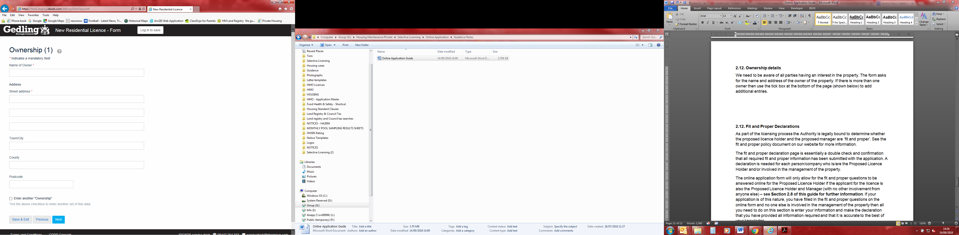

## 2.13 Details of Freeholders and Leaseholders

After entering the ownership details, the form will ask about the Freeholder and Leaseholder information.

Ownership of property is generally split into freehold and leasehold. When a property is purchased it will be clear whether the purchase is for the freehold and/or the leasehold. Not all properties have a leasehold. If you are unsure consult Land Registry, your mortgage provider or documentation from when you purchased the property. If the freehold or leasehold is different to the ownership details entered previously you will be required to provide further information on the freeholders/leaseholders.

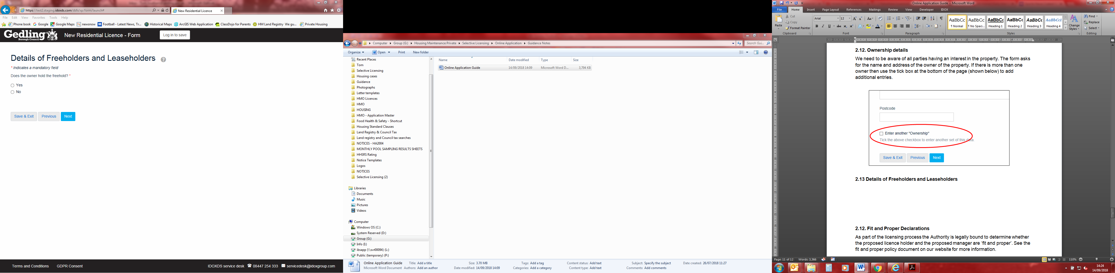

## 2.14. Mortgage

If there is a mortgage provider then that would make them a party who have an interest in the property. Select whether you have a mortgage or not using the ‘Yes’ or ‘No’ check boxes. If you select ‘Yes’ you will be required to enter the details of the mortgage provider.

When processing the licence, a land registry search will be carried out. The search will show whether there is a mortgage on the property. If you haven’t entered this information on your form accurately it could result in a delay in processing your application.

If there is more than one mortgage on the property use the tick box at the bottom of the ‘Mortgage Details (1)’ page to add additional information.

## 2.15 Details of Charges

For more information on Legal Charges please see the Land Registry website [Practice guide 29: registration of legal charges and deeds of variation of charge - GOV.UK (www.gov.uk)](https://www.gov.uk/government/publications/registration-of-legal-charges-and-deeds-of-variation-of-charge/practice-guide-29-registration-of-legal-charges-and-deeds-of-variation-of-charge). It is not unusual for properties to have more than one legal charge. Provide as much detail as you can in relation to any charges on the property. To provide details or multiple charges use the tick box at the bottom of the page (shown below).

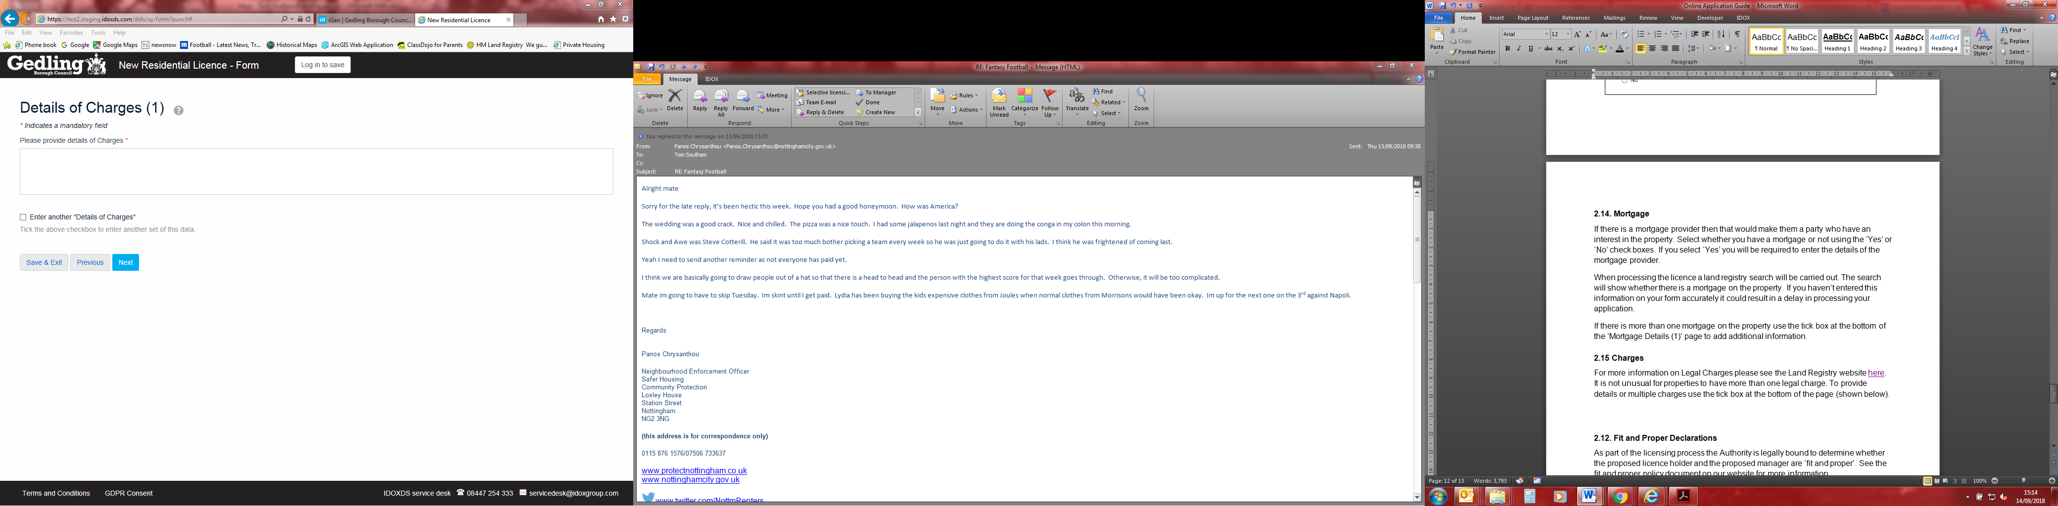

## 2.16. Fit and Proper Declarations

As part of the licensing process the Authority is legally bound to determine whether the proposed licence holder and the proposed manager are ‘fit and proper’. See the fit and proper policy document on our website for more information.

The fit and proper declaration page is essentially a double check and confirmation that all required fit and proper information has been submitted with the application. A declaration is needed for each person/company who is/are the Proposed Licence Holder and/or involved in the management of the property.

The online application form will only allow for the fit and proper questions to be answered online for the Proposed Licence Holder if the applicant for the licence is also the Proposed Licence Holder and Manager (with no other involvement from anyone else) – see **Section 2.8 of this guide for further information**. If your application is of this nature, you have filled in the fit and proper questions on the online form and no one else is involved in the management of the property then all you need to do on this section is enter your information and make the declaration that you have provided all information required and that it is accurate to the best of your knowledge.

For all scenarios where the applicant isn’t both the Proposed Licence Holder and Manager (where there is no other involvement in the management from any other party) you will need to download the Fit and Proper Persons Form from our website. This document needs to be completed by the Proposed Licence Holder and Manager (if applicable), signed on page 4 by all persons and then attached to your application via the file upload page (See **Section 2.19)**. The Fit and Proper Persons Form can be completed and signed electronically or printed off, filled in by hand and scanned back in. A declaration needs to be made on the online form for each person who has then completed the fit and proper information. To add additional people use the tick box at the bottom of the form shown in the image below.

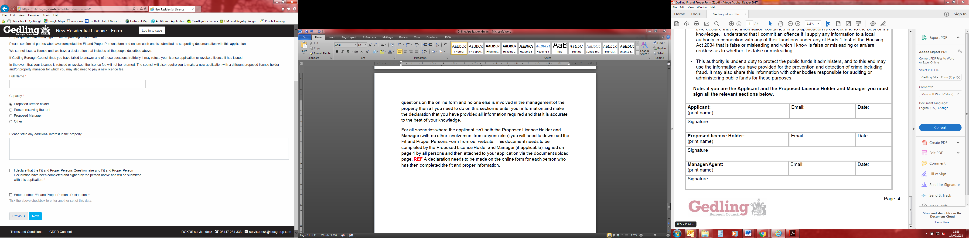

## 2.17. Property Management

This part of the application aims at gathering further information on management arrangements for the property. As part of the licensing process the authority is required to assess whether the management arrangements are satisfactory. The questions in this section are fairly self-explanatory. Depending on how these questions are answered further information may be required as you progress.

**Note:** Some questions in this section only apply to HMO (Houses in Multiple Occupation) licence applications. These questions are clearly marked. If you are making a Selective Licence application the answers submitted for these questions will not be used when processing your application. There is one text box which requires a text entry before progression is possible. If you are applying for a Selective Licence type ‘n/a’ into the text box.

## 2.18. Details of the Property

We are legally required to ask certain questions about the property on the application form. As with the Property Management part of the form, some of the questions are only applicable to HMO applications (See **Section 2.17** of this guide).

One question asks whether the property has a gas supply. Even if you enter ‘No’ to this question you will progress onto a page asking you if you have completed a Gas Safety Certificate in the last 12 months and then further onto a page asking for the date of the certificate. Unfortunately this is an issue with the form that we have been unable to resolve with the developer. If the property does not have a gas supply select ‘No’ to the question about the Gas Safety Certificate and then when you are asked for the date of the certificate simply click ‘Next’ without entering a date. The same applies to the Electrical Safety Certificate questions.

You will then progress onto a page entitled ‘Further Details of the Property’. It states on this page that this section only applies to HMO licence applications however a number of these questions are relevant to Selective Licence applications. Answer all questions in this section accurately for both HMO and Selective applications.

## 2.19. File upload page

This is how you upload your supporting information to your application form. There is a list on this page of what documents are essential (these must be submitted with your application either via this upload facility or via post within 5 working days from the date you submit your application for your application to be considered valid). The desirable documents would be helpful for us when processing your application and would help to demonstrate high levels of management however not submitting these will not affect your application. To upload documents click on the ‘browse’ button and select the document from the location you have it stored on your computer. Once you have selected the file click ‘open’. Repeat this process until all documents you wish to attach have been uploaded.

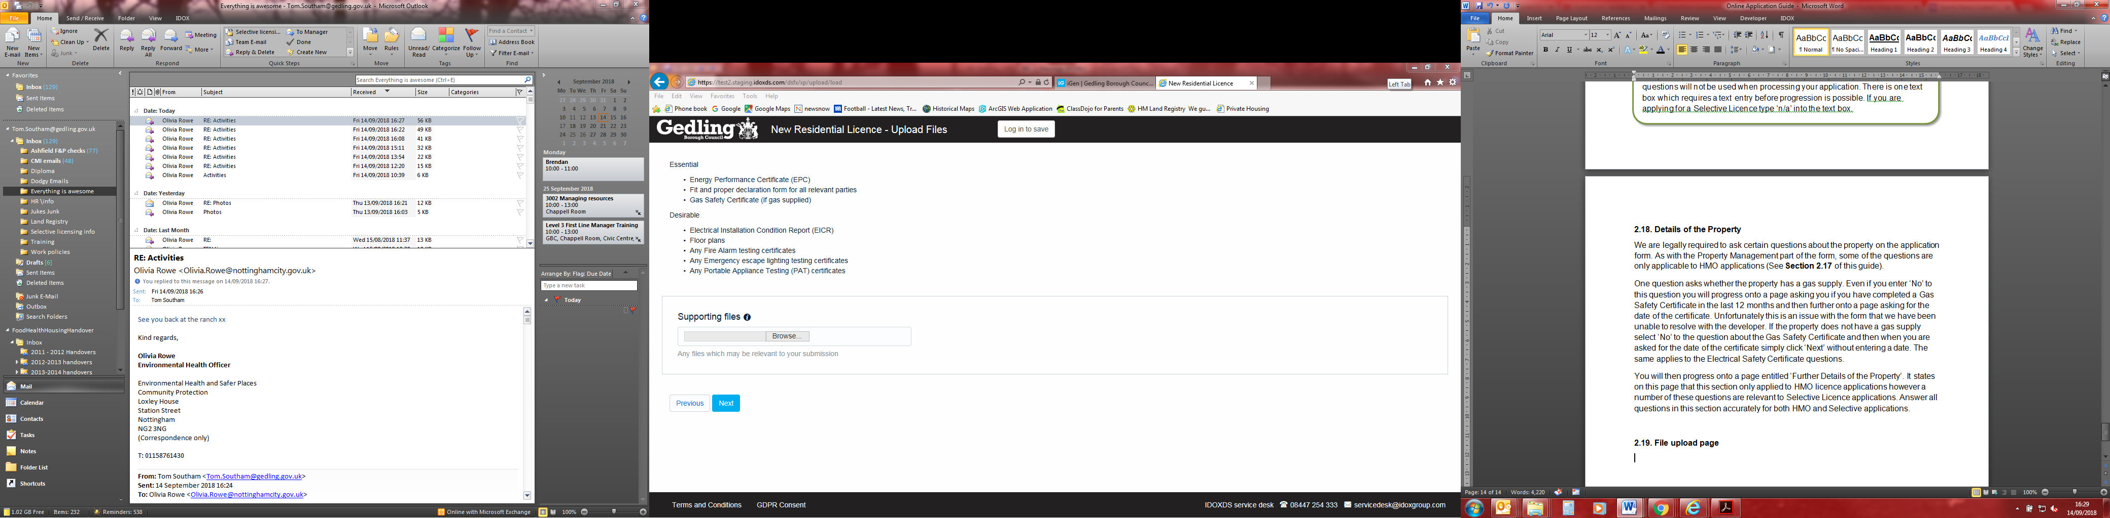

## 

## 2.20. Supporting Documentation

This page is a final checklist for the applicant to ensure that no supporting documentation has been omitted. Once on this page if you realise you have forgotten to attach any of the required documents you can return to the file upload page by using the ‘previous’ button.

If you do not have a document in the list i.e. you do not have a Gas Safety Certificate because the property doesn’t have a gas supply select N/A.

## 2.21. Notification Requirements and Notification Declaration

There is a duty on the applicant to inform certain persons in writing that the application has been made to the local authority. This can be done by writing to each party or by providing copies of your licence application in full. The persons who need to be notified are as follows:

* Any mortgagee of the property to be licensed
* Any person who has had a registered charge on the property
* Any owner of the property to which the application relates (if that is not you) i.e. the freeholder and any head lessors who are known to you
* Any other person who is a tenant or long leaseholder of the property or any part of it (including any flat) who is known to you other than a statutory tenant or other tenant whose lease or tenancy is for less than three years (including a periodic tenancy)
* The proposed licence holder (if that is not you)
* The proposed managing agent (if any) (if that is not you)
* Any person who has agreed that he will be bound by any conditions in a licence if it is granted.

You will be navigated to a page entitled **Person and Address Declaration (1).** Here the details of all people who have been notified/are to be notified need to be entered. This includes a description of the person’s interest in the property. Additional entries can be made using the tick box at the bottom of the page shown to the right.

The box entitled ‘Date of Service’ is the date on which the person was notified. This can be a future date as it is accepted that notification may happen after the date of application.

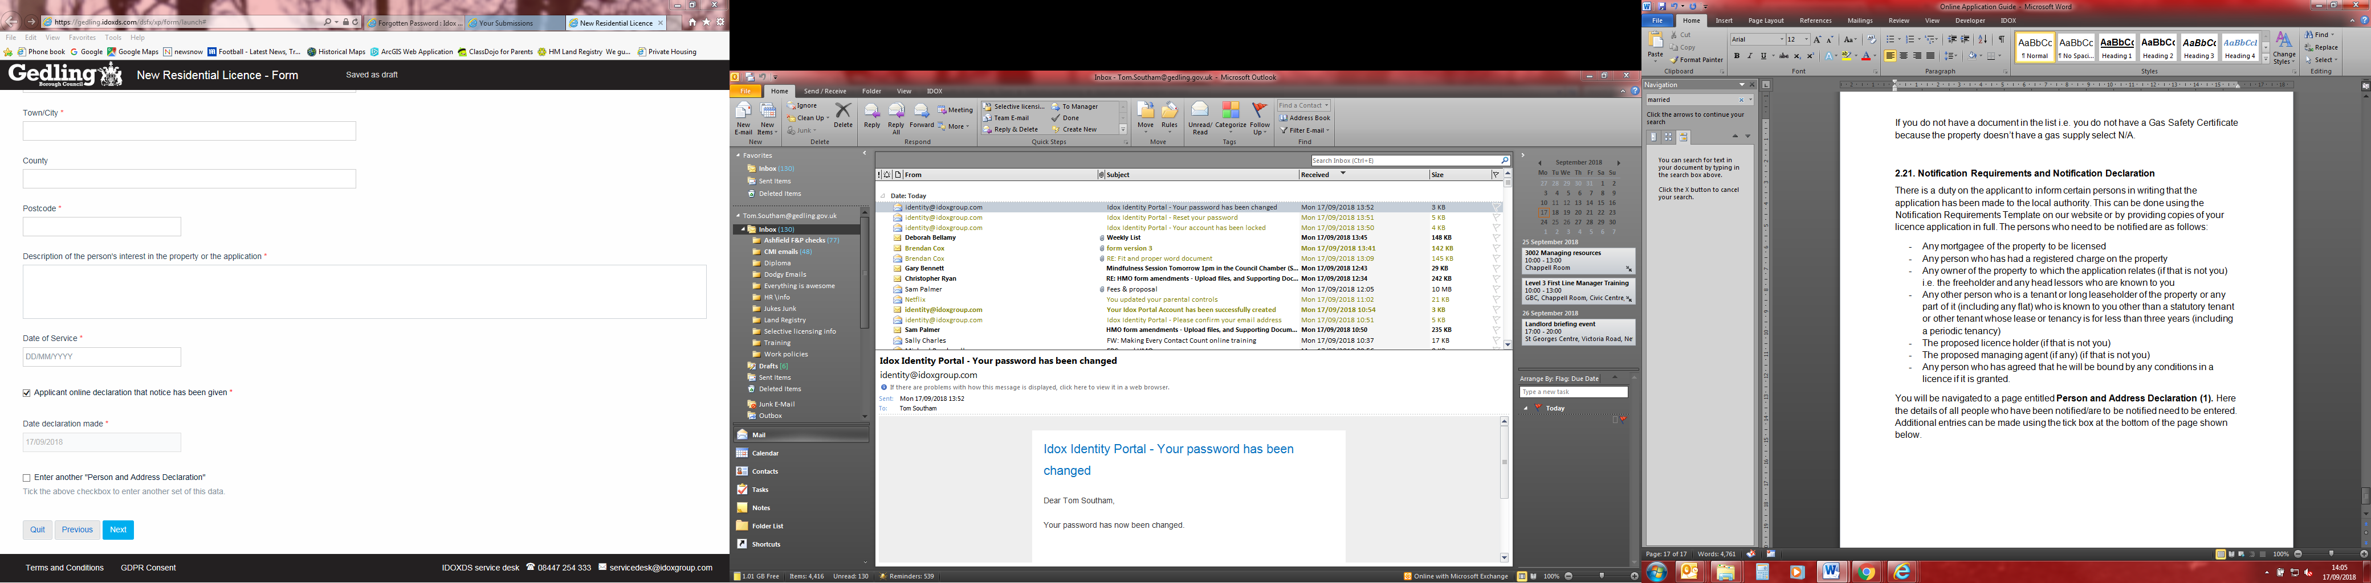

Once all notified persons’ details have been entered the person filling out the form will then be required to make a declaration that all have been duly notified on the form shown below.

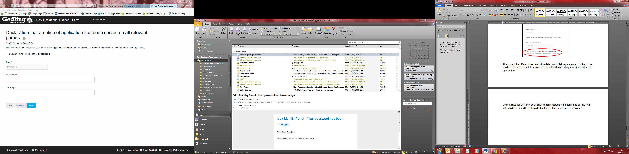

## 2.22. Declarations (Final Declaration)

At the top of this page the applicant will be asked whether they are willing to receive licence documentation via email. If you select ‘yes’, the email addresses previously entered in the application will be used to deliver documentation.

A final declaration is needed using tick boxes, finished with the name and capacity of the person making the declaration.

## 2.23. Email confirmation

It is very important that the information entered on this page is correct to ensure that you receive the email confirmation of your application being submitted and the application reference number. Ensure that you keep your email confirmation safe as it is your proof of submission and you will need the reference number when paying the second part of the fee prior to your licence documents being sent out.

## 2.24. Fee Breakdown

At this stage of the application you will be given a fee summary. This is Part 1 of the licensing fee which must be paid to submit your application. Part 2 will be payable once your application has been processed and the draft documents are ready to be sent out. The fee on this page is automatically calculated based on the information you have entered in the application form and will reflect any accreditation discount. The fee cannot be changed.

## 2.25. Application Review

The final page before being redirected to Gedling Borough Council’s payment system is an application review page. Here you are provided with your unique reference number and a link to your application in PDF format for your records (accessed by clicking ‘Preview’). It is recommended that you save a copy of the PDF for your records.

## 2.26. Payment Screen

When you select ‘Submit and pay’ on the application review page you will be redirected to the Gedling Borough Council Payment screen. Once you have completed the payment you will be provided with a payment reference. Please take a note of this reference number and keep it in a safe place.

After submission you will receive a confirmation email from Idox with your application reference number and a PDF version of the application form for your records. You will also receive a separate email from Capita with details of the card payment.

**Please note that the application form will not be submitted to us until you have entered you card details and progress through the payment process.**